Project Design Phase-II
Data Flow Diagram & User Stories

Date | 5 April 2026
Team ID | SWTID-2026-9677
Project Name | Automating employee data
Maximum Marks | 4 Marks

Data Flow Diagrams:
The DFD shows how employee data moves in the system. Employee details from external files (Excel/CSV/XML) are uploaded into ServiceNow using Import Sets. The data is stored in a staging table, validated, and then transformed using Transform Maps. Finally, the data is stored in the main employee table (sys_user) for easy access and use.
Example:
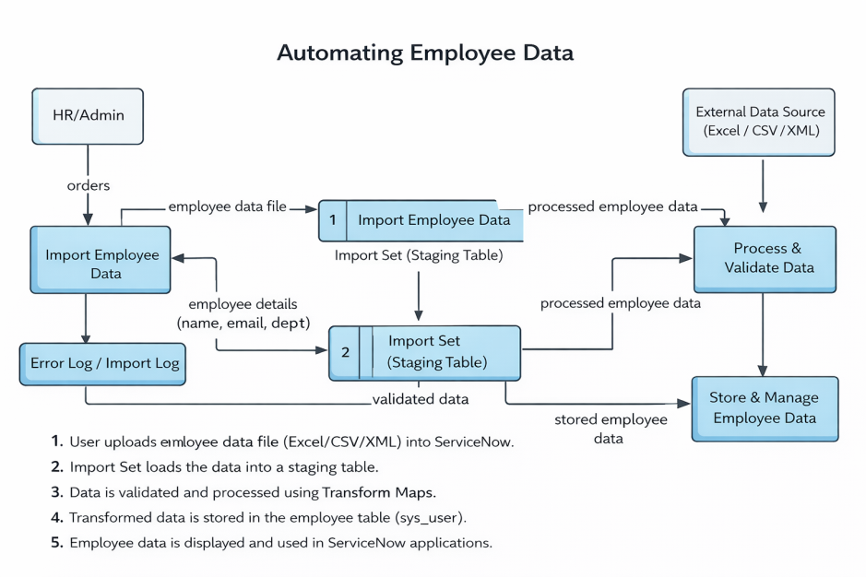
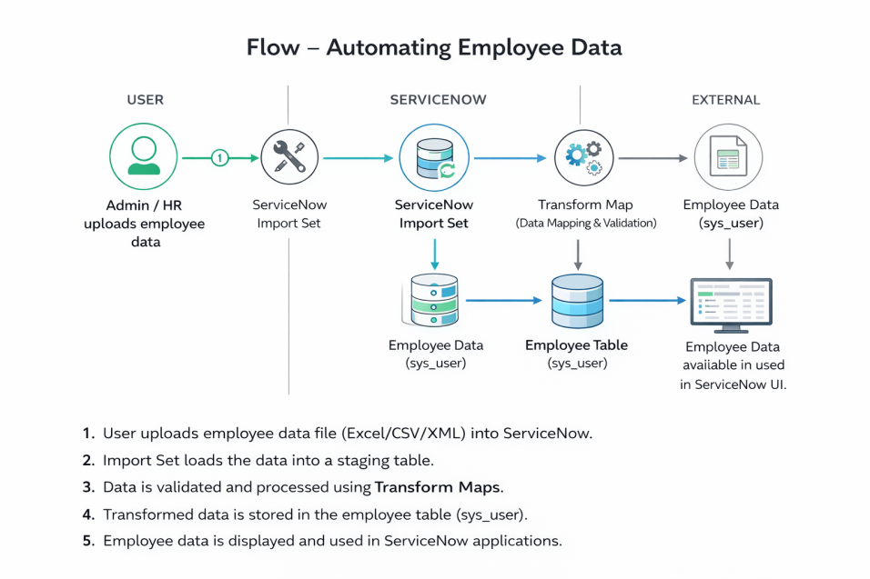

User Stories

User Type | Functional Requirement (Epic) | User Story Number | User Story / Task | Acceptance criteria | Priority | Release
Service Now Admin | Data Import Setup | USN-1 | As a Service Now Admin, I want to upload employee data (CSV/XLSX) so that it can be stored in the system | File is uploaded successfully and data appears in import table | High | Sprint-1
ServiceNow  Admin | Data Import  Setup | USN-2 | As an Admin, I want the system to automatically create an import table (import_employee) | import table is created with all uploaded records | High | Sprint-1
ServiceNow  Admin | Data  Transformation | USN-3 | As an Admin, I want to create a Transform Map to move data from import table to user table | Transform map is created and linked to correct tables | High | Sprint-1
ServiceNow  Admin | Data  Transformation | USN-4 | As an Admin, I want to map fields like Name, Email, Department, and Manager | All fields are correctly mapped without errors | High | Sprint-1
ServiceNow  Admin | Data Validation | USN-5 | As an Admin, I want to validate transformed data to ensure accuracy | Data is correctly inserted into sys_user table | High | Sprint-1
ServiceNow  Admin | Error Handling | USN-6 | As an Admin, I want the system to log errors for missing or incorrect data | Errors are logged without stopping the process | Medium | Sprint-2
ServiceNow  Admin | Form  Configuration | USN-7 | As an Admin, I want to configure the Incident form to show employee details | Fields are added and visible on form | High | Sprint-2
IT Support Agent | Incident  Management | USN-8 | As an IT Support Agent, I want to see employee department on Incident form | Department auto-displays when user is selected | High | Sprint-2

